2019 - 2020 Direct Lending ADDITIONAL UNSUBSIDIZED Loan Request Form

Please complete information below in blue or black ink.
REQUIRED: You must be enrolled in a minimum of 6 credit hours each term you request funds.

DELAY IN DISBURSEMENT NOTICE: First-time borrowers are subject to a mandatory 30–day hold of first disbursement of loan funds. Loans are always disbursed in two payments over the term of the loan.

PLEASE NOTE: To avoid delays in processing, answer ALL questions and initial any changes you make to your written information.
Incomplete forms will not be processed.
NORMAL PROCESSING TIME IS 4 - 6 WEEKS AFTER YOUR FILE IS COMPLETED. Please refer to the Financial Aid Calendar for expected disbursement dates.

STUDENT BORROWER INFORMATION:

Name
MCC Student ID

REFERENCES:
Please list two persons with different U.S. addresses who have known you for at least three years.

LOAN INFORMATION and APPLICATION PROCESS:
The Loan Request Form provides the MCC Financial Aid Office with necessary information to process a Federal Master Promissory Note. You must have exhausted your base loan eligibility before you can be considered for an Additional Unsubsidized Loan. The following step should be completed before your Federal Direct Loan Application will be processed.
Log in to NSLDS using your FSA User ID and password. Print and attach your Financial Aid Review results. (See instructions on page 2.)

STUDENT BORROWER:
- MCC Expected Graduation Date (Month and Year REQUIRED): /
MONTH YEAR
- Declared program of study at MCC (Degree)

- Please indicate the total amount you wish to apply for: $ .00

Maximum Yearly Amounts: | $2000 | Dependent Student
 | $6000 | Independent Students
- Please check the period of attendance (only one) for which loan funds are requested:

Fall Only Fall & Spring Spring Only Spring & Summer Summer Only AUTHORIZATION;
Your signature is required and certifies the following:
You have completed the required Entrance Counseling and Master Promissory Note and authorize Morgan Community College to request loan funds on your behalf as indicated above.

Student’s Signature Date

NOTICE OF NON-DISCRIMINATION
MCC employees and students shall not be subjected to unlawful discrimination and/or harassment on the basis of sex/gender, race, color, age, creed, national or ethnic origin, physical or mental disability, veteran status, pregnancy status, religion, genetic information, gender identity, or sexual orientation in its employment practices or educational programs and activities. Lack of English skills will not be a barrier to admission to, or participation in, the college. For more info, including where to direct inquiries, visit: http://www.MorganCC.edu/about-mcc/legal-notices.

(Continue to Step 2 – OVER)

2019 - 2020 Direct Lending ADDITIONAL UNSUBSIDIZED Loan Request Form STEP 2

You must complete ALL steps outlined below. Incomplete forms cannot be processed.

Go to the National Student Loan Data System (NSLDS) at www.nslds.ed.gov
  - Log in to NSLDS using your FSA User ID. (The FSA User ID replaces the four-digit PIN used prior to May 10, 2015 for ALL Federal Student Aid processes). If you do not yet have an FSA User ID, click on the “Create AN FSA ID” tab to create. See example below.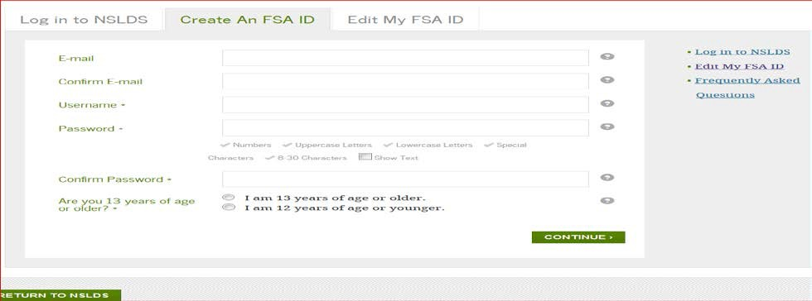
Once logged in to NSLDS, the system should take you directly to your ‘Financial Aid Review’ where you can review the Federal Student Aid that you have received in your higher education history. (Federal Student Loans and Federal Pell Grant Funding)
  - Print your history summary and attach to the Additional Unsubsidized Loan Request Form (this form) and submit for processing.
  - If you have no Federal Student Aid history, you will receive a message stating such and you will need to print and attach the ‘no history’ statement to this form and submit for processing.
  - Please be aware of the maximum amounts of aid that you can draw from Federal Student Aid:

Federal Pell Grant Lifetime Limit: 600% = 6 years full-time enrollment, or 12 semesters at full-time enrollment

Federal Student Loan Limits for Morgan Community College:

Year | Dependent Students (except students whose parents are unable to obtain PLUS Loans) | Independent Students (and dependent undergraduate students whose parents are unable to obtain PLUS Loans)
First-Year Undergraduate Annual Loan Limit (Students with less than 30 earned credits at MCC) | $5,500—No more than $3,500 of this amount may be in subsidized loans. | $9,500—No more than $3,500 of this amount may be in subsidized loans.
Second-Year Undergraduate Annual Loan Limit (Students with 30+ earned credits at MCC) | $6,500—No more than $4,500 of this amount may be in subsidized loans. | $10,500—No more than $4,500 of this amount may be in subsidized loans.
Subsidized and Unsubsidized Aggregate Loan Limit | $31,000—No more than $23,000 of this amount may be in subsidized loans. | $57,500 for undergraduates—No more than $23,000 of this amount may be in subsidized loans.  $138,500 for graduate or professional students—No more than $65,500 of this amount may be in subsidized loans. The graduate aggregate limit includes all federal loans received for undergraduate study.

